Architectural Requirements Document
Product Name: CDE Curation Tool
Version 3.1

Submitted to: NCI Center for Bioinformatics

Prepared by:



Bill McCurry
101 West Renner Road, Suite 130
Richardson, TX 75082

Contact Information:
E-mail bmccurry@scenpro.com
Telephone 972/437-5001
FAX 972/437-3611
Revision History

Authors/Responsible Party | Revision Number | Page(s) Effected | Date
Dan Grandquist | Original | All | Nov 15, 2004
Sumana Hegde | R1 | 1,4,5 | Jan 3, 2005
Tom Phillips | R2 | 6 | Jan 3, 2005
Sumana Hegde | R4 | 3,4,5,6 | Feb 22, 2005
Bill McCurry | R3 | 6 | Mar 2, 2005
Larry Hebel | R5 | 1 | Mar 4, 2005
Sumana Hegde | R6 | 5,6 | Feb 14, 2006
Larry Hebel | R7 | All | Feb 21, 2006

Introduction
The purpose of this document is to outline the architectural design that will be used in the development of the CDE Curation Tool Version 3.1 to be released as part of caCORE 3.1. This document will explain the system architecture and data flows for this system.

Architecture Diagram
The CDE Curation Tool will implement the Model-View-Controller (MVC) architecture, illustrated in the architectural diagram below.

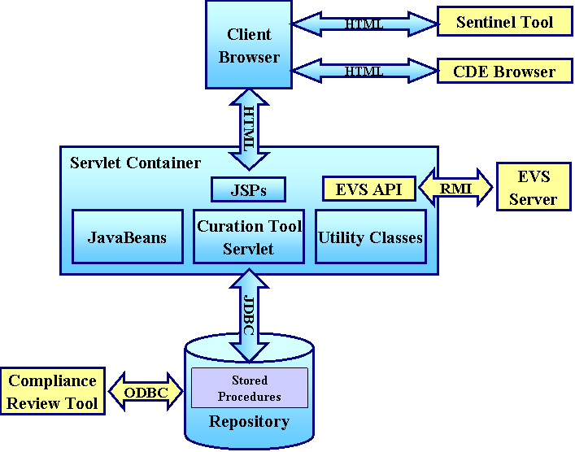

Figure 1 - Curation Tool Architecture Diagram

A JSP user interface in the browser window communicates with a controller servlet running within the Tomcat Servlet engine under JBoss. The controller servlet handles system processing and navigation, while Java Server Pages (JSP’s) display the views.

Authentication is handled via the Oracle JDBC connection to the caDSR database server.

The servlet accesses the database using Oracle JDBC connections. A pool of connections is established on startup of the servlet container and connections are retrieved from the pool as needed. All connections are returned to the pool after each data request.

Model data retrieved from the Oracle database is stored as key-value pairs in JavaBeans.

Utility classes are instantiated by the servlet as needed for program processing.

An integration point has been established with the Compliance Review Tool (CRT) so that users of the CRT that need to create a new Data Element will be able to seamlessly complete the process in the CDE Curation Tool.

Users are able to search the Enterprise Vocabulary System (EVS) for terms using the caCORE EVS API.

The Curation Tool also allows the user to view detailed information for a selected data element by linking to the CDE Browser.

A caDSR Sentinel Tool can be accessed using Curation Tool to setup e-mail notification for changes to administered components in caDSR database.

The Curation Tool also uses the Sentinel Tool Utility API for service requests to the Sentinel Tool.

Curation Tool Flow Diagram
The flow diagram below illustrates the paths a user may take through the program to create or edit administered components.

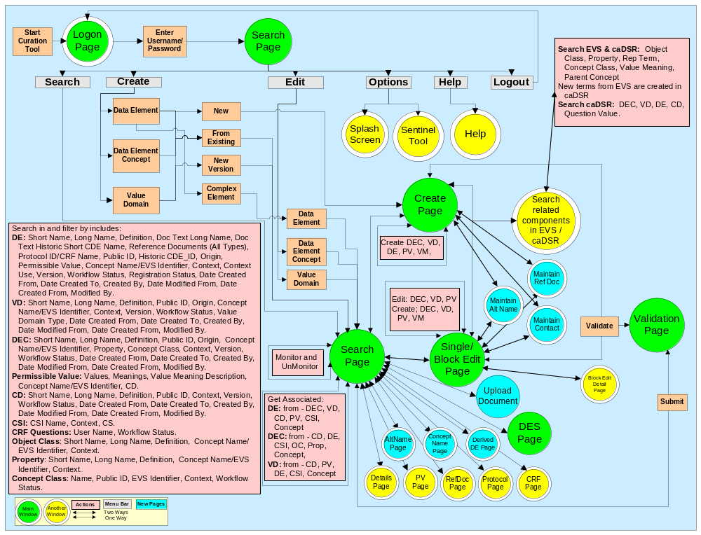

Figure 2. CDE Curation Tool Flow Diagram

Integration with Other Tools
The Curation Tool accesses the EVS server to search for concepts and definitions for administered components. Once used, EVS concepts are saved in the caDSR as Concepts. To conduct EVS searches the Curation Tool uses the caCORE EVS API. This API calls certain stored procedures, which must be loaded on the EVS Database server for the searches to return records.

The Curation Tool is integrated with the CDE Compliance Review Tool. An integration point has been established with the CRT, so that a user of the CRT who needs to create a new Data Element will be able to seamlessly complete the process in the CDE Curation Tool. From the CRT a user can press a hyperlink to open the Curation Tool to an initial search results page. When user selects CRF Questions to search from the dropdown list and click on search button, the tool shows a list of draft new questions, ordered by sequence number, from the CRF assigned to that user. When user clicks on a result, a Complete Selected DE button enables. When Complete Selected DE button is clicked, Create/Edit DE page opens and the selected question is pasted into document text field, and context field is filled by the CRF question’s context. The user is able to search for and select a DEC, create a new DEC or Edit a DEC. Likewise, user is able to search for and select a VD, create a new VD or Edit VD. While creating or editing VD, search for Permissible Values Hyperlink opens a pop-up window showing the values from the CRF, so the user may search for the permissible values in caDSR for the CRF values, and create new permissible values. To assign this newly created permissible value to valid value from CRF, users search permissible values and select the desired valid value. After the DEC and VD have been selected or created, the user finishes creating the DE. After validation, the new DE is submitted to the caDSR, the Data Element’s and Value Domain’s IDs are written to the quest_contents_ext table, and the user is returned to the original list of questions. After a DE has been created for each question, the user returns to the CRT tool to complete the review.

The Curation Tool provides a link to the CDE Browser, allowing users to view the details of the selected data element. Curation Tool users may search for a data element and from the search results page may select a data element by clicking the check box next to it. This enables the details button on the page. When the user clicks on the details button, the Curation Tool connects to the CDE Browser, opening a page with the complete details of the selected Data Element from the Curation tool.

The caDSR Sentinel Tool can be opened using Curation Tool. A menu item “Sentinel Tool” under “Options” on the Curation Tool main menu opens the Sentinel Tool in a separate window. The Sentinel Tool can be used to setup e-mail notification for changes to administered components in the caDSR database.

The Curation Tool also accesses programmatic features of the Sentinel Tool through the Sentinel Tool Utility API. The required JAR is packaged in the Curation Tool WAR file. At runtime the Sentinel Tool Utility API sends requests and retrieves responses through an HTTP connection to the Sentinel Tool. All requests send a user ID however a password is not sent. The request authentication is made solely on the user ID.

